**E-commerce website where the client wishes to sell certain products.**

**Informations:**

* The store can be accessed via a PC through a browser or a mobile device with Chrome Version: 119.0.6045.160 or higher.
* When the link is accessed, a login interface with two fields (username, password) and a “Login” button will appear.

Notes:

* If the credentials are incorrect => message: “Epic sadface: Username and password do not match any user in this service”
* If the username field is left blank => message: “Epic sadface: Username is required”
* If the password field is left blank => message: “Epic sadface: Password is required”
* The fields accept any type of character
* The password field will display hidden characters
* There is no maximum character limit
* After authentication, a page with available products will appear.

**On the products page, we have the following:**

* The company logo centered at the top
* A menu button with:
* All Items (home button)
* About (redirects to testing tools products)
* Logout
* Reset app state (not to be tested)
* A shopping cart icon in the top right corner
* Below the shopping cart, a sorting filter for products with the following options:
* Name (A to Z)
* Name (Z to A)
* Price (low to high)
* Price (high to low)

**The products are displayed as follows:**

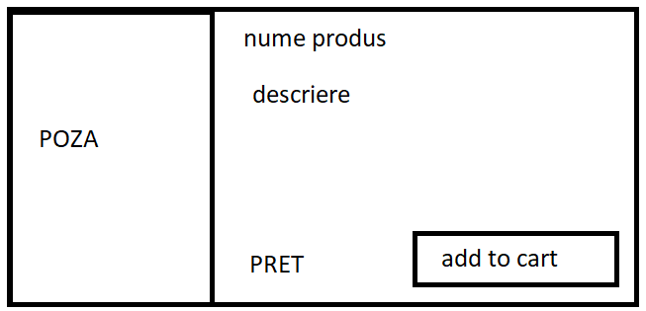

* When the product name or picture is clicked, a new form with that product (the same product information) opens.
* The "Back to products" option is a button located in the top left, below the "menu" button.
* When a product is added to the cart, the "add to cart" button changes to "remove."

**When the shopping cart is accessed, the following are displayed:**

* Information about the product(s) added to the cart and their quantity.
* Next to each product, there is a "remove" button to delete products from the cart.
* In the bottom left, a "continue shopping" button redirects to the "product list" form.
* In the bottom right, a "checkout" button redirects to the "Checkout" form.

Notes:

* For an empty shopping cart, the "Checkout" button should be disabled.
* The shopping cart should retain added products even if the user logs out.

**In the "Checkout" form, we have:**

* 3 fields to complete:
* First name
* Last name
* Zip/PostalCode
* A "Cancel" button at the bottom left
* A "Continue" button at the bottom right

Notes:

* If the "First name" field is left blank => message: “First name is required”
* If the "Last name" field is left blank => message: “Last name is required”
* If the "Zip/Postal Code" field is left blank => message: “Zip/PostalCode is required”
* Any type of character is accepted in these fields.
* After pressing the "Continue" button, the application will redirect to the "checkout overview" form.
* After pressing the "Cancel" button, we will be redirected to the shopping cart.

**In the "Checkout review" form, we have the following:**

* A description with the products in the shopping cart (quantity and price)
* Payment information
* Shipping information
* A section with the total price (the sum of all products plus a fee)
* A "Cancel" button at the bottom left, which redirects to the "product list"
* A "Finish" button that redirects to a page informing you that the order has been placed (in this form, there is an informational message "Thank you for your order!" and a "back home" button at the bottom center, which redirects to the "product list")

Notes:

* After returning to the main page/product list, the shopping cart should be empty.